**SOFTWARE DESIGN DOCUMENT**

**Project:** Obstacle track-racer – A competitive robot design project

**Task:** Design and implement a working model out of EV3 Lego sets that would autonomously navigate to a racetrack on an island shown in the world map and complete as many laps as possible within the 5-minute time limit, eventually returning to its starting point.

**Document Version:** 3.01

**Date:** 23/03/2021

**Author:** Lide Cui, Angelina Duan, Dominic Chan

**Edit History:**

|  |  |  |  |
| --- | --- | --- | --- |
| Version 1.01 | 25/02/2021 | Lide Cui | Work on the initial document. |
| Version 1.02 | 03/03/2021 | Dominic Chan | Formatting and Template of document |
| Version 2.01 | 05/03/2021 | Lide Cui | Detailed design of avoiding obstacles |
| Version 2.02 | 12/03/2021 | Lide Cui | Add state machine |
| Version 2.03 | 13/03/2021 | Lide Cui | finish obstacle avoidance, navigation,  review abstract |
| Version 3.01 | 23/03/2021 | Angelina Duan | initial version of thread layout and update class hierarchy and flow chart |

**1.0 TABLE OF CONTENTS**

**2.0 ABSTRACT** 1

**3.0 SOFTWARE FLOWCHART AND WORKFLOW** 2

**4.0 STATE MACHINE** 2

**5.0 CLASS HIERARCHY** 4

**6.0 DESIGN OF DIFFERENT FUNCTIONS** 4

**6.1 LOCALIZATION** 4

**6.2 NAVIGATON** 5

**6.3 OBSTACLE AVOIDANCE** 5

# **2.0 ABSTRACT**

In this software document, the **state machine** and game play **flowchart** describe the sequential behavior of the robot. All implemented methods are described respectively with a brief description. The algorithm of all main methods is illustrated in a flowchart form. A **class diagram** is also included to showcase the structure of the software for this project. Lastly, this document contains a **weekly log** to demonstrate the evolution of the robot’s software as well as the feedback that was received by the testing team.

Also, some detailed descriptions of functions, such as navigation, localization, and obstacle avoidance, are provided.

# **3.0 SOFTWARE FLOWCHART AND WORKFLOW**

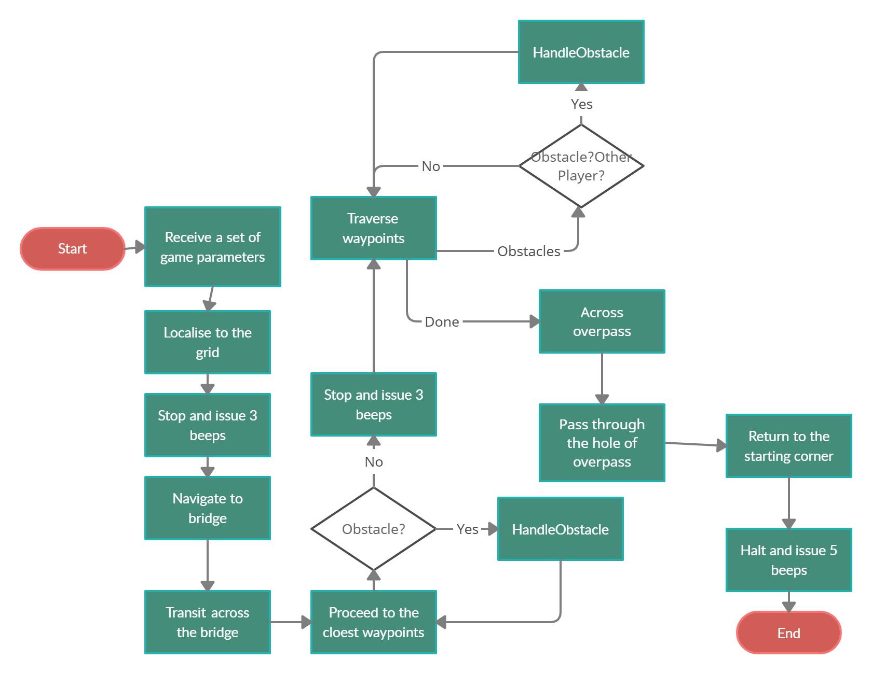

*Figure 1 Flow Chart*

**4.0 STATE MACHINE (CONTROL IMPLEMENTATION)**

*Figure 2 State Machine*

*Transition:*

*Event 0: Parameter Received*

*Event 1: Position Determined*

*Event 2: Find Tunnel Location*

*Event 3: Arrive at Competition Yard*

*Event 4: Find Bridge Location*

*Event 5: Arrive at the Other Side of Bridge*

*Event 6: Iterate All the Points*

*Event 7: Detect Obstacles*

*Event 8: Arrive at the Safe Point*

*Event 9: Time Approaches 5 Minutes*

# **5.0 CLASS HIERARCHY**

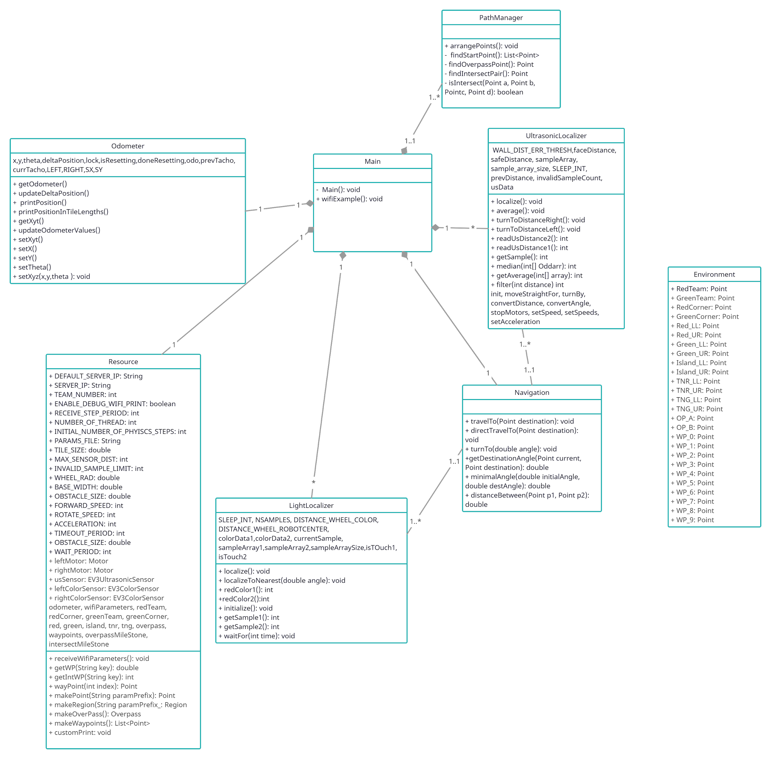

*Figure 3.class diagram*

Only public methods are shown in the class diagram, for they can be used by other classes. Private methods are subject to change.

# **6.0 DESIGN OF DIFFERENT FUNCTIONS**

## **6.1 LOCALIZATION**

（Refer to Lab5 report)

## **6.2 NAVIGATON**

Title: General Navigation

Actor: Robot, Obstacles

Intention: The intention for the robot is to cross the bridge, run laps and return home within 5 minutes.

Precondition: The robot has received all parameters and finished localization.

Main Scenario:

1. The robot turns to the bridge and moves to the edge of the bridge.

2. The robot moves across the bridge.

3. The robot moves the closest waypoint.

4. The robot locates itself, and if there is time left, the robot moves the next waypoint (back to step 3).

5. The robot returns to the edge of the bridge.

6. The robot across the bridge.

7. The robot moves to the starting point.

Alternative\Exception #1:

3a. If there is an obstacle, then run the obstacle avoidance process, continue at step 4.

Alternative\Exception #2:

Notes:

The edge of the bridge is the midpoint between TNR_UR_x and TNR_LL_x.

The distance of the bridge is TNR__UR_y and TNR_LL_y.

The estimated return time is at 4’10’’.

## **6.3 OBSTACLE AVOIDANCE**

Title: Avoid an Obstacle

Actor: Robot, Obstacles

Intention: The intention of the robot is to safely avoid an obstacle by passing by it and move to the destination point.

Precondition: The robot has accurately located a point, turned by a minimal angle towards destination point, and calculated the distance to the destination.

Main Scenario:

1. The ultrasonic sensor of the robot measures distance to the nearest ‘obstacle’.

2. The robot divides the path into 3 parts.

3. The robot travels the first part (the length of first part = distance to obstacle – react distance).

4. The robot turns 90 degrees and detects if there is enough space to turn.

5. The robot moves the second part (the length of second part = 3*obstacle size + 2* react distance).

6. The robot turns -90 degrees.

7. The robot moves third part to the destination point (the length of third part = distance to destination – length of first part – obstacle size – 2 * react size).

Alternative\Exception #1:

1a. If the distance to obstacle is greater or equal to distance to destination, then the main scenario is jumped, the robot directly travels to the point.

Alternative\Exception #2:

1b. If the path of current position and destination position pass through an overpass, then the main scenario is jumped, the robot directly travels to the point.

Alternative\Exception #3:

4a. If the robot detects a wall so that it has no sufficient space to turn

4a.1. The robot turns 180 degrees.

4a.2. The robot does step 5.

4a.3. The robot turns 90 degrees and continues from step 7.

Postcondition: The robot approaches the destination point and starts the localization process.

Notes:

React distance is estimated to be 0.1 m.

7.0 THREAD LAYOUT

The following figure shows the thread organization of the final project:

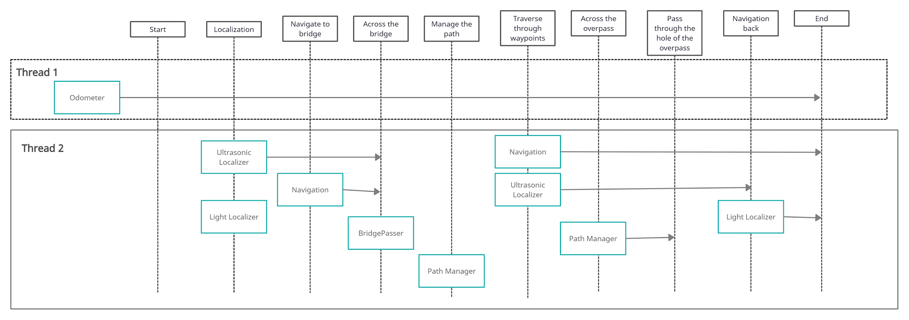

*Figure 4. Sequence diagram*

We separate all states into two different threads and components in threads are parallel. The first thread is used for the odometer so that we can drive the robot no matter what tasks it needs to do and they are used in many processes throughout the design. The second thread is used for localization, navigation, bridge passer, and path manager, processes inside are linked to each other.

The upper thread organization diagram has lifelines, showing the main process of the robot. When the robot receives game parameters, the localization happens at first. Then the robot knows where it is, we start the bridge localization. Once the bridge is localized, the robot crosses the bridge. Now, the path manager comes, this method finds the closest point as startpoint, rearrange the waypoints list, and finds the point across the overpass. Then, it’s time to use the navigation class to traverse waypoints. During this thread, the robot has the ability to cross the overpass or pass through the hole of the overpass. Obstacle Avoidance needs to be used throughout the processes in each thread or even methods. Lastly the robot needs to return to its starting point.